The major architectural components of the Teradata Vantage engine include the Parsing Engines (PEs), BYNET, Access Module Processors (AMPs), and Virtual Disks (Vdisks). Vdisks are assigned to AMPs
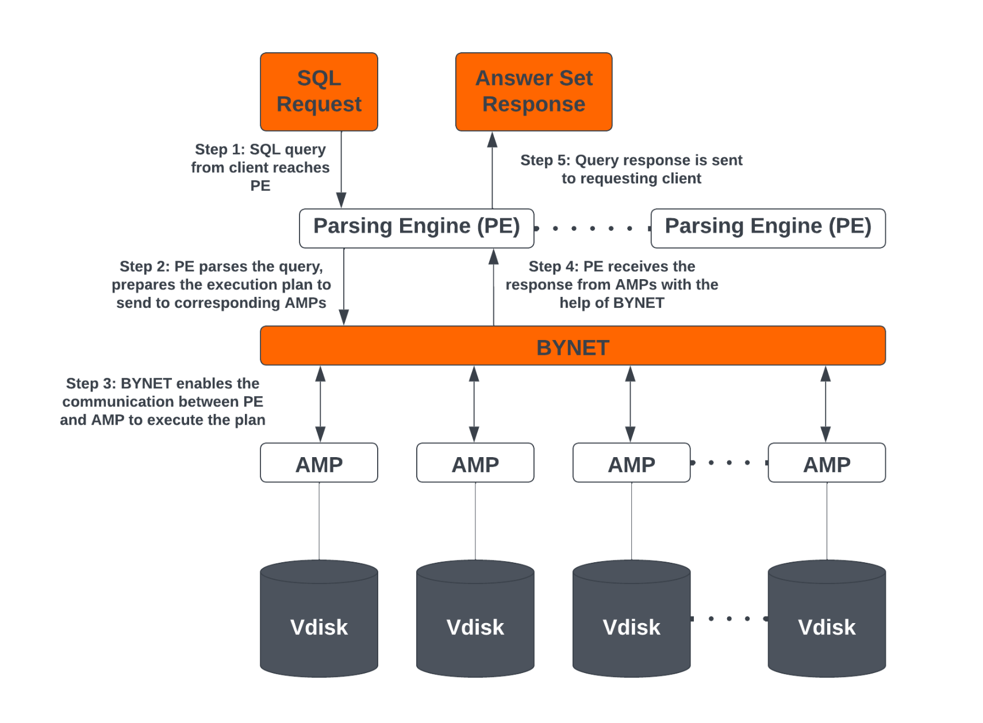

The Parsing Engine is responsible for:
- Managing individual sessions (up to 120)
- Parsing and Optimizing your SQL requests
- Dispatching the optimized plan to the AMPs
- Input conversion (EBCDIC / ASCII) -if necessary
- Sending the answer set response back to the requesting client

The following are the processes performed by PE:
- Parser: The Parser checks for the syntax, if true forward the query to Session Handler.
- Session Handler: it does all the security checks, such as checking of logging credentials and whether the user has permission to execute the query or not.
- Optimizer: It finds out the best possible and optimized plan to execute the query.
- Dispatcher: The Dispatcher forwards the query to the AMPs.

2. Message Passing Layer

The Message Passing Layer (MPL) or Communications Layer handles the internal communication of the Teradata Database. All communication between PEs and AMPs is done via the Message Passing Layer.

The Message Passing Layer or Communications Layer is responsible for:

- Carrying messages between the AMPs and PEs
- Point-to-Point, Multi-Cast, and Broadcast communications
- Merging answer sets back to the PE
- Making Teradata parallelism possible
Important:
Depending on the nature of the dispatch request, the communication may be a:
Broadcast – message is routed to all AMPs and PEs on the system
Multi-Cast – message is routed to a group of AMPs
Point-to-Point – message is routed to one specific AMP or PE on the system

3. The Access Module Processor (AMP)
The Access Module Processor (AMP) is responsible for managing a portion of the database. An AMP will control some portion of each table on the system. AMPs do all of the physical work associated with generating an answer set including, sorting, aggregating, formatting and converting.

The AMPs are responsible for:
- Accesses storage using Teradata’s File System Software
- Lock management- Sorting rows
- Aggregating columns
- Join processing
- Output conversion and formatting
- Creating answer set for client
- Disk space management
- Accounting
- Special utility protocols
- Recovery processing

AMPs are also responsible for Teradata File System Software:
- Translates DatabaseID/TableID/RowID into location on storage
- Controls a portion of physical storage
- Allocates storage space by “Cylinders”

4.Virtual Disks
- Teradata offers a set of Virtual Disks for each AMP. The storage area of each AMP is called as Virtual Disk or Vdisk.
- These are actual physical data storage units which are accessed/manipulated by AMPs on user requests.
- A Virtual Disk is disk space associated with an AMP. Tables/data rows are stored in this space. A virtual disk is usually assigned to two or more disk drives in a disk array. This concept will be discussed in detail later in the course.

Here's a more concise version of the information about **Partitioned Primary Index (PPI)** in Teradata:

---

### **Partitioned Primary Index (PPI) Overview**

A **Partitioned Primary Index (PPI)** in Teradata is an indexing mechanism that partitions a table based on a specified range or case, improving query performance. PPI is similar to a **Primary Index (PI)** in that it governs data distribution, but it additionally sorts rows within partitions.

### **Key Features of PPI:**
- **Improved Query Performance**: Enhances performance for range queries by partitioning data, reducing the number of rows scanned.
- **Partition Elimination**: Only relevant partitions are read, speeding up data retrieval.
- **Efficient Data Loads**: Improves incremental data loading and deletes by working with partitioned data.
- **Partitioned Storage**: Rows within each partition are sorted by their row hash, reducing the amount of data read for specific queries.

### **Characteristics:**
- PPI can be defined on **volatile**, **global temporary**, and **permanent tables**.
- The **partitioning column** doesn't need to be part of the non-unique Primary Index but must be part of the unique Primary Index.
- Partitioned tables reduce the data processed for range queries through partition elimination.
- Supports **multi-level partitioning**.

### **Advantages:**
- **Avoids full table scans** for specific queries.
- **Reduces overhead** by eliminating the need for secondary indexes (SIs).
- **Faster access** to subsets of large tables.
- **Quickly drops and adds data** for incremental loads.

### **Disadvantages:**
- If the partitioning column is not part of the primary index, it can slow down single row lookups.
- **Additional storage** required (2 extra bytes per row).
- **Slower joins** when a PPI table is joined with a non-partitioned table.

### **Types of PPI:**
1. **Case partitioning**
2. **Range-based partitioning**
3. **Multi-level partitioning**
4. **Character-based partitioning**

---

This summary captures the essential points about PPI in Teradata, providing an overview of its functionality, benefits, and potential drawbacks. Let me know if you need further clarification!

Contiguous Maps:
- A contiguous map covers a range of AMPs, usually all AMPs in the configuration
- The contiguous map named TD_MAP1 is created as the default, all AMP map on most systems
- Large tables should be assigned to contiguous maps so they can be distributed across all AMPs
Sparse Maps:
- A sparse map is defined within a parent contiguous map
- The single AMP sparse map named TD_1AmpSparseMap_nNode is created on systems, using the parent contiguous map TD_Map1 (where n is the number of nodes)
- A multiple AMP sparse map named TD_nAmpSparseMap_nNode is created on systems with two or more nodes, using the parent contiguous map TD_Map1 (where n is the number of nodes)
- The CREATE MAP statement may be used to create other sparse maps
- A sparse map utilizes a single AMP, or a small number of AMPs, within the range of AMPs parent map, based on a hash of the table name or the name specified in the COLOCATE USING expression of the CREATE TABLE statement
Guidelines
–
- A table is a good candidate for a sparse map if the permanent (perm) space of the table is “tiny” or “small”
- A general guideline is to first calculate the amount of perm space needed to store all the table’s rows, excluding the overhead for the table’s header
- To calculate a rough estimate of a table’s row perm space use
RPS = (16 + average row length) * number of rows
- If RPS < 128 KB it is a “tiny” table and is a good candidate for the single AMP sparse map (TD_1AmpSparseMap_nNode)
- For other tables calculate number of AMPs = round up (RPS / 128 KB)
- If the number of AMPs is less than the number of nodes it is a “small” table and may be a good candidate for the multi AMP sparse map (TD_nAmpSparseMap_nNode)
- Frequently referenced “tiny” and “small” tables, such as dimensional tables, are the best candidates for sparse maps
- Empty tables are not good candidates for sparse maps as their actual perm space during usage is unknown and may grow significantly, resulting in severe skew of data and processing
- Similarly tables whose perm space will grow past the “tiny” and “small” table guidelines are not good candidates for sparse maps due to the excessive growth on a small number of AMPs
- Use the Teradata Viewpoint Map Manager portlet to analyze and automate the movement of tables into the appropriate map
- The view TDMaps.TableToSparseMapSizingV performs calculations to provide initial recommendations and may be used monitor table growth
- Tables that having matching primary indexes to support AMP local joins should be defined to the same contiguous map or the same sparse map with a matching COLOCATE USING name

1. Teradata Active System Management (TASM)
✅ Advanced workload management solution
✅ Requires a separate license (Enterprise-level)
✅ Provides priority scheduling, workload classification, SLG (Service Level Goals)
✅ Includes workload throttles, filters, and exception handling
✅ Offers query banding and tactical workload optimization
✅ Provides historical insights with Teradata Viewpoint

2. Teradata Integrated Workload Management (TIWM)
✅ Basic workload management, included with the database (No extra license)
✅ Limited to workload classification and priority assignments
✅ Does not support advanced SLG management or throttles
✅ Suitable for smaller environments with fewer workloads
Filters :
Filters allow logons and requests to be rejected before they are executed.
- Filters are system level TASM rules that can reject logons or requests before they consume system resources
- Filters can be defined with the normal classification criteria including the request source, target, query characteristics, query band, and utility criteria
- Filters are very useful for rejecting problematic query requests (e.g., unconstrained product joins against large tables) before they consume resources and are eventually cancelled due to exception criteria
- Filters can be created in Warning Only mode, which is useful during initial testing phases to ensure the classification criteria have been properly set

Scenario – Data Maintenance
- An application team has noticed an anomaly within the data in a reporting table and would like to prevent anyone outside of their team from accessing the data until the issues is resolved during a change control later in the week
- A few application and audit team members still need access to the data to fully assess and plan for resolving the issue
- Notifications have been sent to all impacted users, but the legal department and the audit team want to ensure absolutely no reporting is done against the data until the issue is resolved
Solution
- Define a filter, initially set as warning only for testing, that rejects requests against the salesDB.sales_audited_metrics table except for the selected users on the application development, audit, and database administration team resolving the issue
- Remove the filter after the data anomaly is corrected

Throttles

Throttles limit the number of concurrent requests, sessions, or load utilities.

Throttles are rules that limit the number of requests, sessions, or load utilities that can run concurrently

Throttles help improve the performance of all requests by reducing contention for finite computing resources (e.g., CPU cycles, AMP worker tasks, and memory)

If a throttle threshold is exceeded, TASM either rejects the request or delays it until the activity goes below the throttle
Throttles can be applied to:
  - Session logons, for non-utility sessions, via the Query Sessions throttle
  - Concurrent SQL requests for the entire system, a virtual partition, a specific workload, or a group of workloads
  - Utilities via the Utility Limits throttle

Query Sessions Throttles
- The Query Sessions throttle limits the non-utility sessions that can log on at the same time
- The Query Sessions can only reject sessions during logon, it cannot delay logons
- If user's logon request is rejected the user must reattempt the logon
- Only request source classification criteria may be used in a Query Sessions throttle, since only information about the logon request is available

Query Sessions Throttle Rule Types Scenario
A query sessions throttle has been defined with a request source classification criteria by Application of BTEQ or SQLA (SQL Assistant) and the throttle limit is set to two.
If the rule type is Collective | - Only two sessions will be allowed to logon via BTEQ or SQLA, from all users combined
If the rule type is Individual | - Only two sessions will be allowed to logon via BTEQ, from all users combined  - Only two sessions will be allowed to logon via SQLA, from all users combined
If the rule type is Member | - Only two sessions will be allowed to logon via BTEQ or SQLA, for each user
If logon requests arrive in the order shown, without any users logging off, the throttle will reject the logon requests as shown, based on each rule type

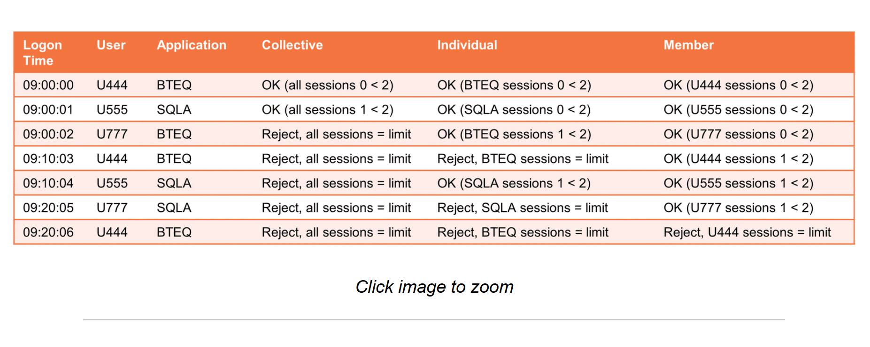

System Request Throttles

Request Throttles
- Request throttles limit concurrent SQL requests
- When a request throttle limit is exceeded TASM either rejects the request or puts the request in a delay queue
- When request activity falls below the throttle limit, the system releases delayed requests in the order specified in the system level General setting Order the Throttle Delay Queue
  - By time delayed – The request delayed the longest is released first
  - By workload priority – The request from the highest priority workload is released first
- If a request is subject to multiple throttles, all throttles the requests is classified into must be below their limit before the request can be released
- If a delayed request is released it cannot be delayed again
- Request throttles may be applied to the entire system, a virtual partition, a specific workload, or a group of workloads

System Request Throttles
- System request throttles (i.e., system throttles) control concurrency of all requests, or a subset of requests, across the entire system
- System throttles can use all classification criteria

System Throttle Rule Types
A Rule Type must be selected when defining a system throttle.

Collective :
All requests that satisfy the classification criteria are throttled as a single group.
Individual :

- Can only be defined with a single classification criteria request source type
- Does not support the query band criteria
- Each source type object that satisfies the classification criteria is throttled as an individual group
- If the classification criteria identifies only a single source type object, the throttle will behave the same as a collective rule type
Member:

Each user that satisfies the classification criteria is throttled at the user level.

System Throttle Scenario – Collective and Member
- An administrator wants to allow only five concurrent requests from users with the profile LawRpt to run concurrently system wide
- To be fair, the administrator wants to ensure no single LawRpt profile user can run more than two concurrent requests
Solution
- Create a system throttle with a classification of request source profile equal LawRpt, a rule type of collective, and a delay concurrency limit of five
- Create another system throttle with the same profile classification, but having a rule type of member, and a delay concurrency limit of two
- Assuming the requests arrive in the order shown and do not complete during the period, this table shows which query requests will be delayed (see table to the right)
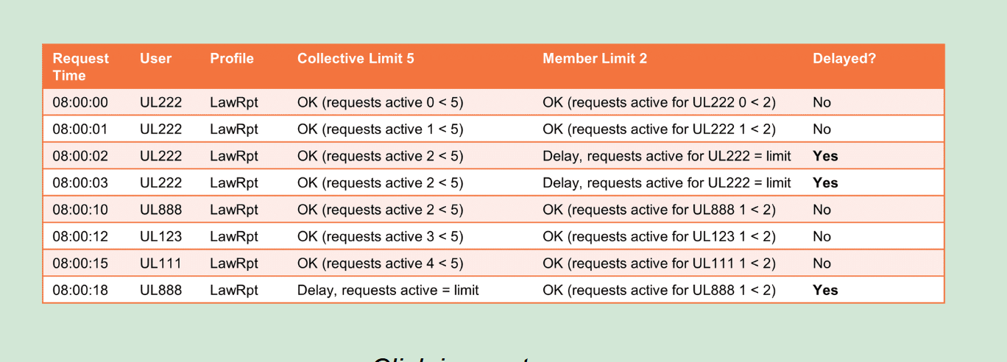

Virtual Partition Request Throttles

Virtual partition request throttles (i.e., virtual partition throttles) manage how many requests can run at the same time in a virtual partition

Virtual partition throttles do not allow the specification of classification criteria, the setting simply controls the limit of requests for various states

Virtual partition throttles can help influence the balance between multiple virtual partitions so one virtual partition does not capitalize the utilization of memory or AMP worker tasks (AWTs)

Consider a relatively lower throttle limit for a virtual partition with complex requests with multiple parallel steps using more AWTs

Consider a relatively higher throttle limit for a virtual partition with shorter, simpler requests using fewer AWTs

Workload Request Throttles
- Workload request throttles (i.e., workload throttles) are the primary tool for limiting work on a system with a complex balance of workloads
- Workload throttles are easier to monitor and to assess request delay times
- If SQL requests in a stored procedure classify to a throttled workload, TASM throttles each request in the procedure individually as each request is submitted

Workload Throttle Scenario – Advanced Analytics
- The current sandbox community includes data scientists that want to exploit the script table operator (STO) of the Teradata Advanced SQL Engine to run Python and R scripts for analytics against sales data within the Teradata Advanced SQL Engine
- The administrator would like to limit the concurrent execution of this new workload to better understand its impact on resource consumption
Solution:
- Define a new timeshare tier workload with a Target Function classification specifying the functions for the STO and ExecR table operator (TD_SYSFNLIB.SCRIPT and TD_SYSGPL.ExecR, respectively)
- Set the concurrency limit of the workload to 1 so the individual queries can exploit the full level of memory resource available, if needed, for these table operators and the resource consumption of individual requests can be better monitored for this new type of workload

Workload Group Request Throttles

Workload group request throttles (i.e., workload group throttles) limit the number of requests that a group of workloads can run concurrently

To qualify for a workload group throttle, a workload must already have an individual throttle and must be active in at least one state

Before a request affected by a workload group throttle can run, it must satisfy both the workload throttle and the workload group throttle

A workload can belong to only on workload group throttle

Workload Group Throttle Scenario – Sandbox Users
- The administrator just added a new workload, Sandbox STO, to limit concurrency for users running R and Python script operators
- The existing non-script table operator requests for these sandbox users are currently assigned to the WD-Low workload which also has a default concurrency limit of three and a critical state limit of one
- The administrator wants to ensure that the combined active requests for these two workloads, Sandbox STO and WD-Low, do not exceed the current limits set for WD-Low
Solution:
- Create a workload group throttle named All Sandbox for grouping the Sandbox STO and WD-Low workloads
- Set the workload group throttle limits to match the WD-Low limits (i.e., default of three and one when critical) so the new workload classification does not increase the overall sandbox requests that may execute concurrently
Workloads
A workload is a group of requests with similar characteristics.

Workload Consumption Hierarchy
- Workloads are defined within a consumption hierarchy that determines the relative percentage of resources that can be utilized
- The top hierarchy level that an administrator can define is a virtual partition
- Within a virtual partition workloads are created in one of three workload management methods which provide more details of the resource consumption hierarchy
  - Tactical tier
  - Service Level Goal (SLG) tiers
  - Timeshare tier

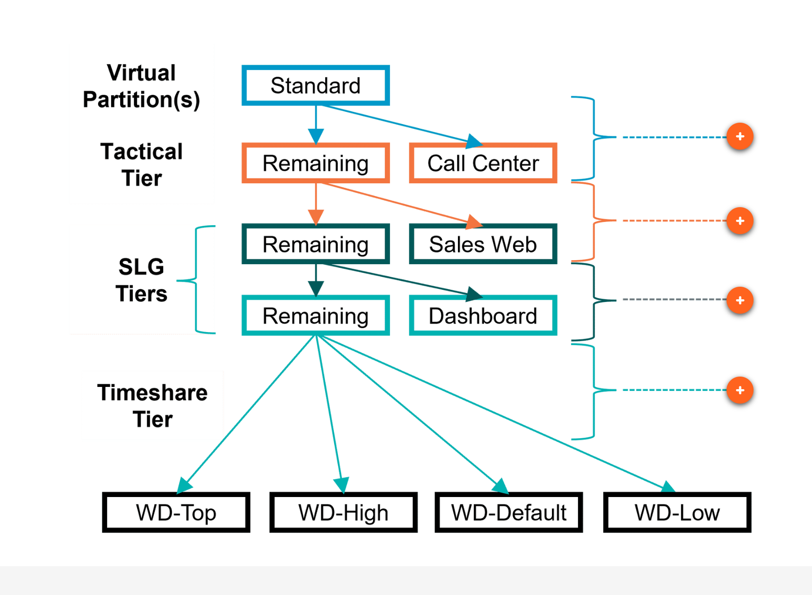
- One virtual partition is the default and is adequate for most configurations
- A single virtual partition is allocated 100% of the system resources
- Multiple virtual platforms are useful to support resource allocation to distinct business units or geographic entities that need to be kept separated
- The system resource allocation percentages for virtual partitions are defined as:
  - Dynamic (soft) – If the other virtual partitions are not using their full allocation, then a busy virtual partition can consume more resources than it is allocated
  - Fixed – The virtual partition cannot consume more resources than allocated, even if the other virtual partitions do not use their full allocation

Virtual Partitions Scenario
- Two business units utilize the Teradata Vantage System
- The Sales organization is the primary source of workload and is expected to consume 85% of the system during the day and 90% of the system during the nightly batch
- The Accounting organization will use the remaining capacity but should be limited to use only 10% of the system during the nightly batch window, even if Sales is not using the full 90%
Solution:
- Within Workload Designer use a dynamic allocation of 85% and 15% for Always (non-nightly batch periods)
- During the nightly batch window Accounting will have a fixed limited of 10% of the system, regardless of Sales usage
- The use of the 10% fixed limit, during nightly batch, may cause the system to be underutilized if the Sales workload does not use its full allocation

Tactical Tier

Tactical Tier Workload Management Method
- The Tactical tier is for workload with critical, very short, highly tuned requests that need a response in one second or less
- Tactical tier workloads consume resources of the owning virtual partition
- Tactical tier queries should be single-AMP or few-AMP requests
- Workloads in the Tactical tier run with an expedited status which orders them higher in the AMP message processing queues and provides access to reserved AMP worker tasks (AWTs)
- Tactical tier requests receive the highest priority available and can consume all the resources they need
- Resources not consumed by the workload in the Tactical tier are passed down the hierarchy to the first SLG tier
- If there is no workload in the Tactical tier all the resources of the virtual partition are available to the first SLG tier
- Hard limits of resource usage are not allowed for tactical workloads
- All tactical workloads are defined with exception criteria to ensure queries exceeding thresholds are reclassified to an appropriate workload

Tactical Tier Scenario
- The Call Center application is used from 9:00 AM through 6:00 PM daily to support the lookup of customer records during interactions with customers
- The business wants to ensure the Call Center queries are given the highest priority so customers can be provided information quickly
- The application which supports the Call Center queries exploits a physical design architecture to ensure the queries are single or few AMP only

Solution
- Classify requests from the Call Center application, which have a specific query band and do not involve all AMP operations, into a Tactical workload named CallCenter
- Set the tactical exception to reclassify queries exceeding the workload's expected resource consumption limits to a lower priority workload
- Set the tactical exception to alert the application owner of any exceptions to allow the review and remediation of potential design issues
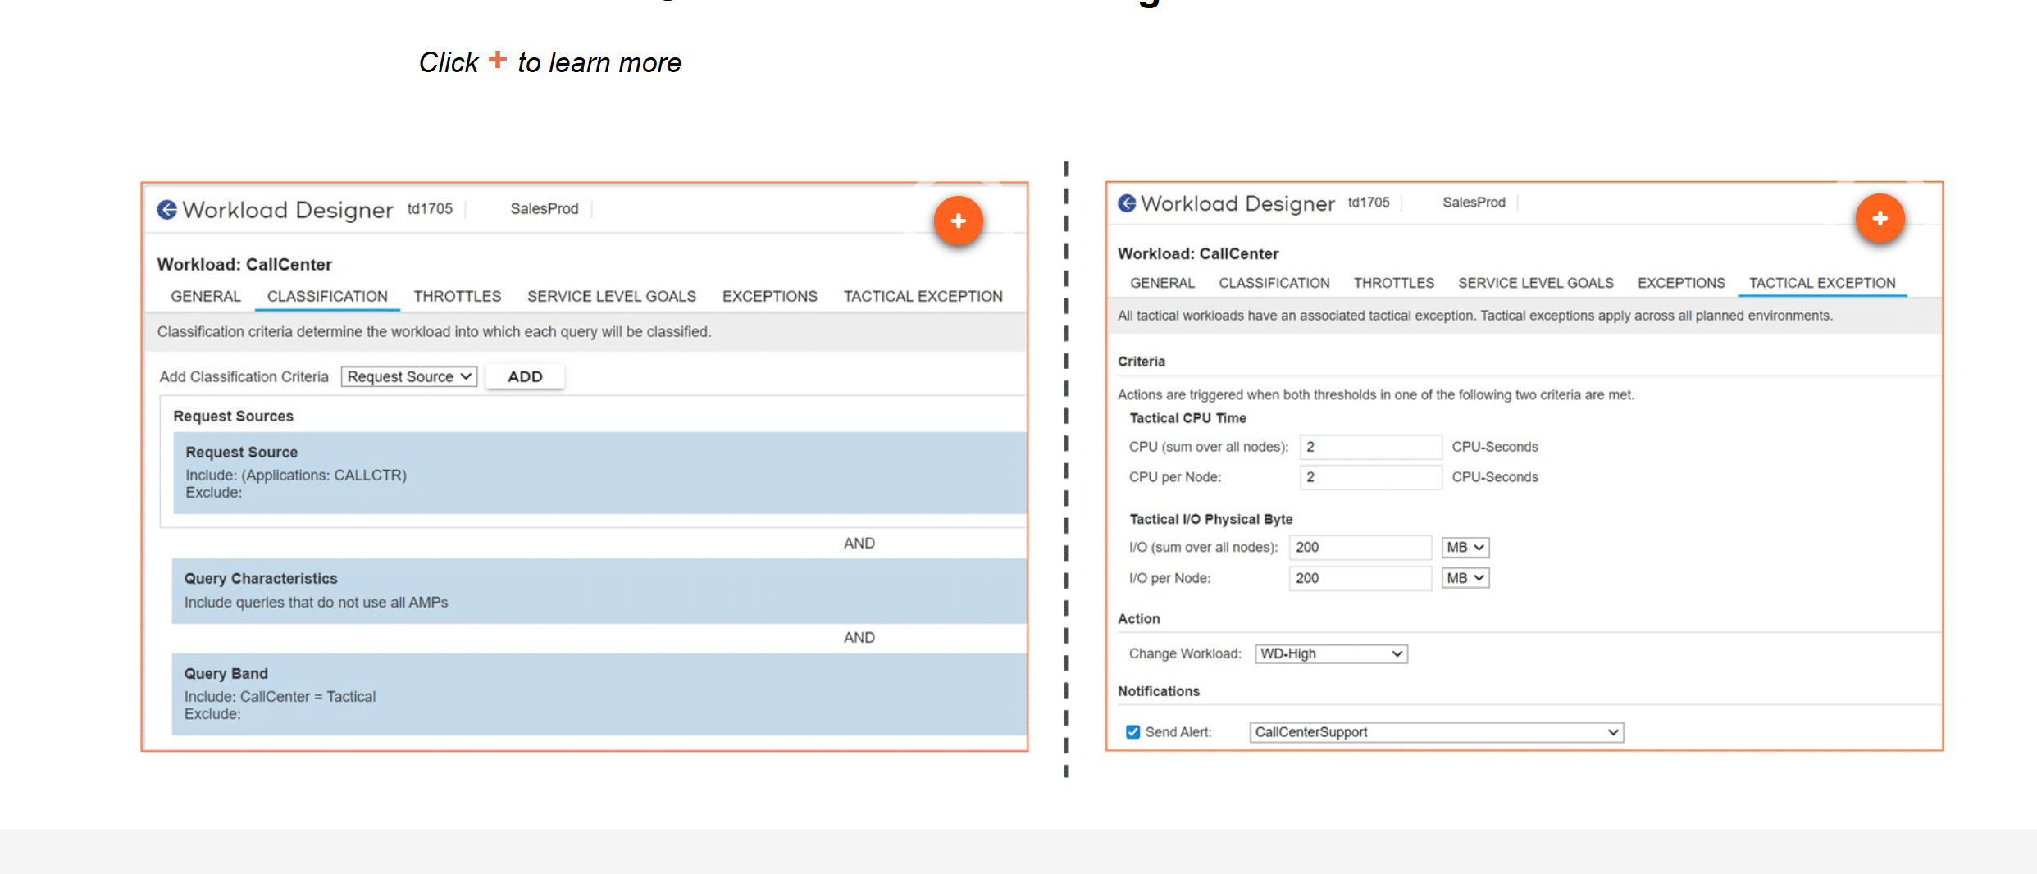

SLG Tier

SLG Tier Management Method
- Resources not consumed by workloads assigned to the Tactical tier flow down to the first SLG tier
- There can be up to five SLG tiers
- Each workload in an SLG tier is assigned a percentage of tier resources to ensure that requests perform consistently and can meet the Service Level Goals for response times and throughput of the workload
- Allocate a slightly higher percentage of tier resources to each workload than originally estimated, to allow for organic growth of the workload
- SLG tier workloads may apply hard limits to system resources, but this can cause system resources to be unused if other workloads are not busy
- SLG tier 1 workloads may optionally have access to expedited AMP message processing queues, but this should only be used for short, critical workloads
- Unused resources flow down to each of the SLG tiers, in SLG tier order, and then to the Timeshare tier

SLG Tier Scenario
- The Sales organization has two applications which submit well defined critical all-AMP queries
- The Sales Web application is expected to use about 15% of system resources
- The Dashboard application is expected to use about 7% of system resources
- Throughput and response time on the Sales Web application has priority over the Dashboard application because the Sales Web application is customer facing

Solution:
- Define the Sales Web application as an SLG tier 1 workload with 16.7% of resources (to allow for organic growth) so it has priority over workload in other SLG tiers and the timeshare tier
- Define the Dashboard application as an SLG tier 2 workload with 10% of resources (to adjust for resources remaining from SLG tier 1 and to allow for organic growth)
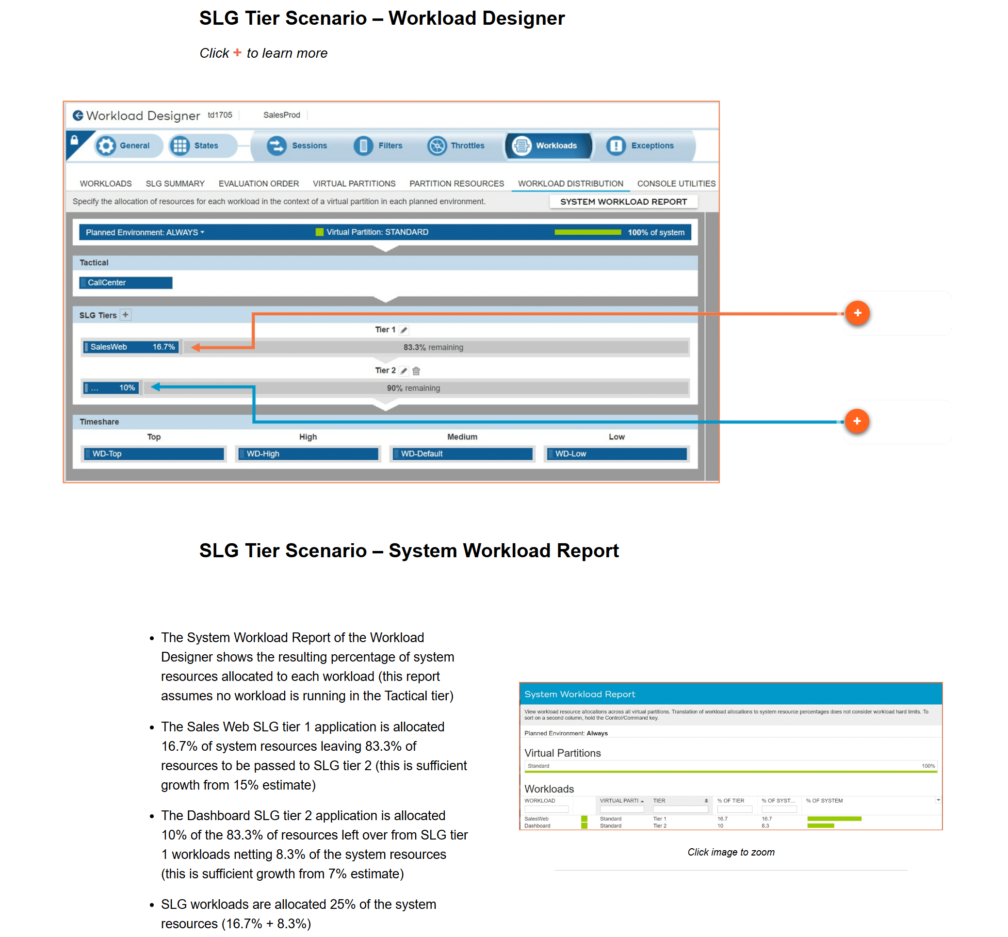

Timeshare Tier

Timeshare Tier Workload Management Method
- The Timeshare tier workloads are at the bottom of the workload priority hierarchy
- The Timeshare tier has four priority levels to which workloads are assigned
- Each priority level is a assigned a relative resource rate:
(see table to the right)

Click image to zoom
- This is interpreted as Top requests get eight times the resources of Low requests
- High requests get four times the resources of Low requests
- Medium requests get twice the resources of Low requests
- If not using SLG tiers, place workload in Top if they are very high priority but do not qualify as tactical

Timeshare Tier Scenario
- In addition to the Call Center, Sales Web, and Dashboard applications the business has additional reporting needs
- Executive reports must have a high priority
- Additional standardized reports run from business intelligence (BI) tools (e.g., Business Objects and MicroStrategy) are time sensitive
- The system will support a sandbox environment with experimental data mining exploration

Solution:
- Classify the sales management report queries in the Top priority level so they are expedited
- Classify the BI tool queries as High priority to meet response time objectives
- Place the sandbox queries in the Low priority since they have no response time objectives
- Default the remaining queries into the Medium priority until analysis shows specific characteristics suggesting placement in other priorities or workloads
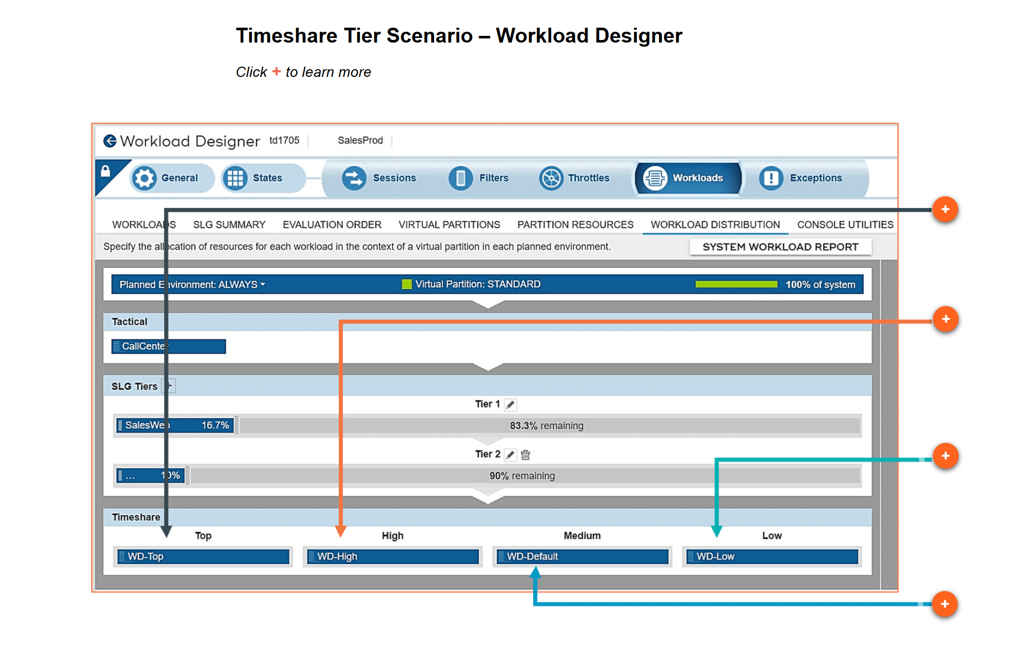
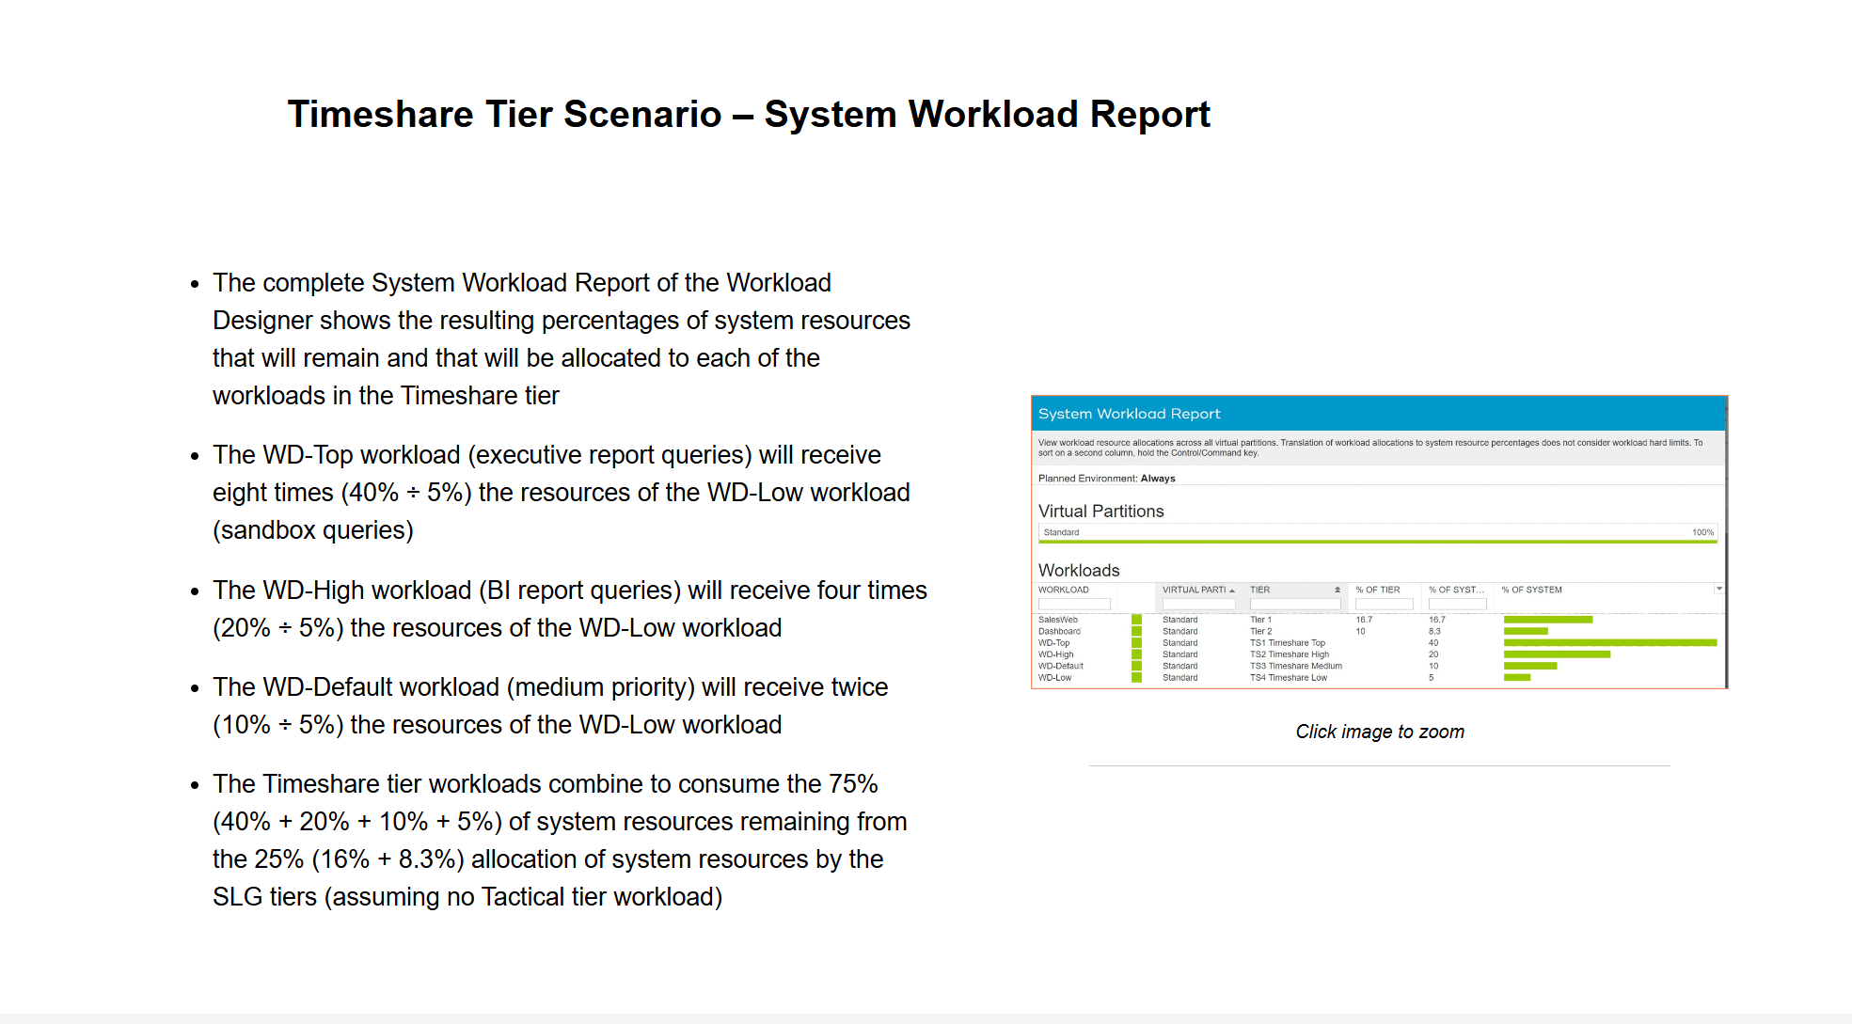

Service Level Goals

Workloads at all tiers (tactical, SLG, and timeshare) may have optional Service Level Goals specified in each workload's definition within the Workload Designer

Service Level Goals can indicate the expected response times or throughput rates for a workload

Service Level Goals can be helpful to document the original performance expectations of a workload and can simplify reporting of how workloads are performing against those original goals

Workload Classification Evaluation Order
- Within the Workloads definitions of the Workload Designer the Evaluation Order tab specifies the order in which workload classification criteria are matched
- The classification criteria shown summarize the specification for each workload
- In the scenario shown, workload WD-Default has no classification criteria as it is used to execute any requests which do not satisfy any other workload classification criteria

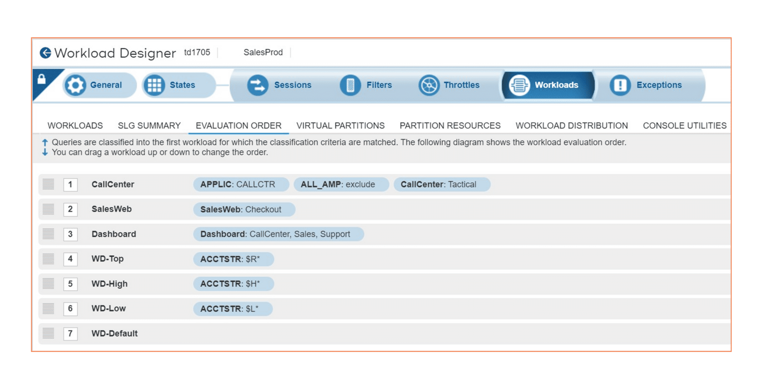 Minimum Response Time
- To manage user expectations about request response times, a minimum response time may be specified for each request in a workload
- TASM prevents requests from responding before the specified time by delaying the return of a request's answer set
- The RESPONSE-HELD parsing engine state indicates that a request response is being held due to a minimum response time
- AMP steps have completed, locks are released, and TASM throttle counters are decremented before a request enters a RESPONSE-HELD state
- Minimum response times are not available for Tactical workloads
- The minimum response time does not affect SET commands and transaction statements
- For stored procedures and macros TASM does not hold the CALL or EXEC statements but it does treat each statement in the procedure or macro as a separate request and will delay each statement

Minimum Response Time Scenario – New Capacity
- The Teradata Vantage system is being upgraded to double the current number of nodes to provide capacity for a new web application being added to SLG tier 1 in the coming months along with organic growth of other workloads
- The administrator is concerned that the queries for the Dashboard workload will now complete twice as fast and the Dashboard users may submit twice the workload, consuming some of the extra capacity before the new web application is implemented
- The administrator is also concerned that the Dashboard users may get an unrealistic expectation that this faster response time is the new normal and will be complain when the new web application workload is added
- The Dashboard workload runs in SLG tier 2 and currently has a service level goal of a response time in five seconds
Solution:
- Set a hold query responses time of four seconds for the Dashboard workload
- This will provide the Dashboard workload users with a consistent experience, as they had prior to the upgrade, while still meeting the workload's service level goal of five seconds
- After the new web application is added the hold query response time can be removed
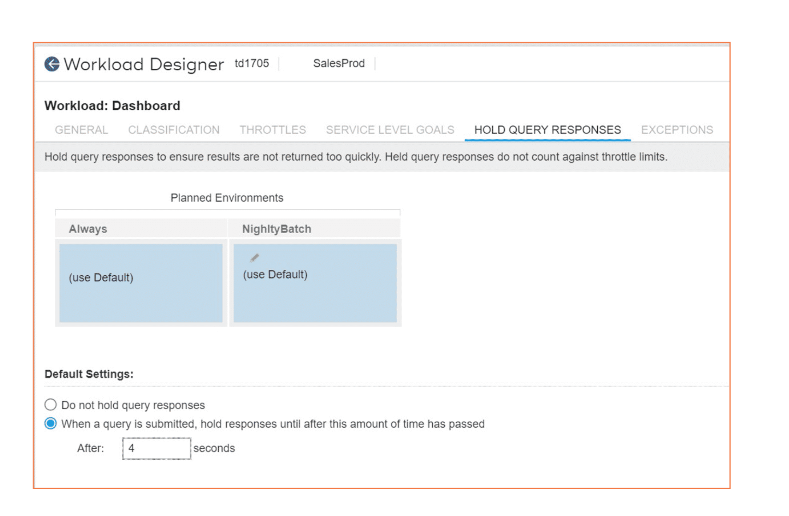

Overview of Resource Usage Data
Resource usage data is stored in system tables and views in the DBC database. Teradata macros generate reports that display the data.s
the tables that can be used to:
- Observe the balance of disk and CPU usage
- Obtain pdisk usage information
- Check for bottlenecks
- Provide an overall history of the system operation
- Monitor the utilization of AMP Worker Tasks (AWTs)

The following table lists the topics covered by resource usage data.
Resource usage data covers … | Which includes …
BYNET traffic on a node | point-to-point messaging, broadcast messaging, and merge activities.
client-to-server traffic | data for each communication link.
CPU utilization | overhead, user service, and time of session execution.
storage device traffic | the number of reads/writes and amount of data transferred as seen from the storage driver.
pdisk device traffic | pdisk I/O, cylinder allocation, and migration statistics.
vdisk device traffic | all the cylinders allocated by an AMP (which can come from any pdisks in the clique).
Priority Scheduler information | - Data by Priority Scheduler WD.  Priority Scheduler is managed by TASM and is configured using the Teradata Viewpoint workload management portlets. For more information on those portlets, see Teradata® Viewpoint User Guide, B035-2206.
AMP Worker Task information | AMP Worker Task statistics.
memory management activity | memory allocation.

Types of Resource Usage Tables
The following table describes the tables and provides guidance about which ones to enable.
Table Name | Covers | When You Should Enable
ResUsageSawt | Data specific to the AMP Worker Tasks. | When you want to monitor the utilization of the AMP Worker Task and determine if work is backing up because the AMP Worker Tasks are all being used.
ResUsageScpu | Statistics on the CPUs within the nodes. | When the performance analysis suggests that the overall performance is limited or to check if a program is spinning in an infinite loop on an individual processor.  For example, saturation of a particular CPU on each node or on a particular node while others are idle could indicate a task always uses that CPU.  Also, you should enable when the system is first brought online to verify the following:  - That all CPUs are functioning on all nodes  - There is a good load balance among the CPUs
ResUsageShst | Statistics on the host channels and LANs that communicate with Vantage. | To determine details about the traffic over the IBM Host channels and if there is a bottleneck.
ResUsageSldv | System-wide, logical device statistics collected from the storage driver. | To observe the balance of disk usage. The storage device statistics are often difficult to interpret with disk arrays attached due to multi-path access to disks.  Use the ResUsageSvdsk table first to observe general system disk utilization unless specifically debugging at a low level.
ResUsageSmhm | Reserved for future use. | N/A
ResUsageSpdsk | Statistics collected from the pdisk device. | To obtain detailed usage information about pdisks.
ResUsageSpma | System-wide node information provides a summary of overall system utilization incorporating the essential information from most of the other tables.  Use the columns in ResUsageSpma to view BYNET utilization.  The BYNET can transmit and receive at the same time, resulting in 100% transmitting and 100% receiving values simultaneously. Another method of determining BYNET utilization and traffic is to use the blmstat tool. | To provide an overall history of the system operation.
ResUsageSps | Statistics based on the WD the work is being performed for. | When you need to track utilization by the WD level.
ResUsageSvpr | Data specific to each virtual processor and its file system. | To view details about the resources being used by each vproc on the system. This table is useful for looking for hot AMPS or PEs that may be CPU bound or throttled on other resources.

https://www.devopsschool.com/blog/teradata-database-architecture/

https://youtu.be/UczqkSymhjQ?si=qjHJwlDL55j8G-u3

